Story 04 Add a Book

## Description

As a user

I want to add a book

So that it will be stored in the database

## Wireframe

Happy case:

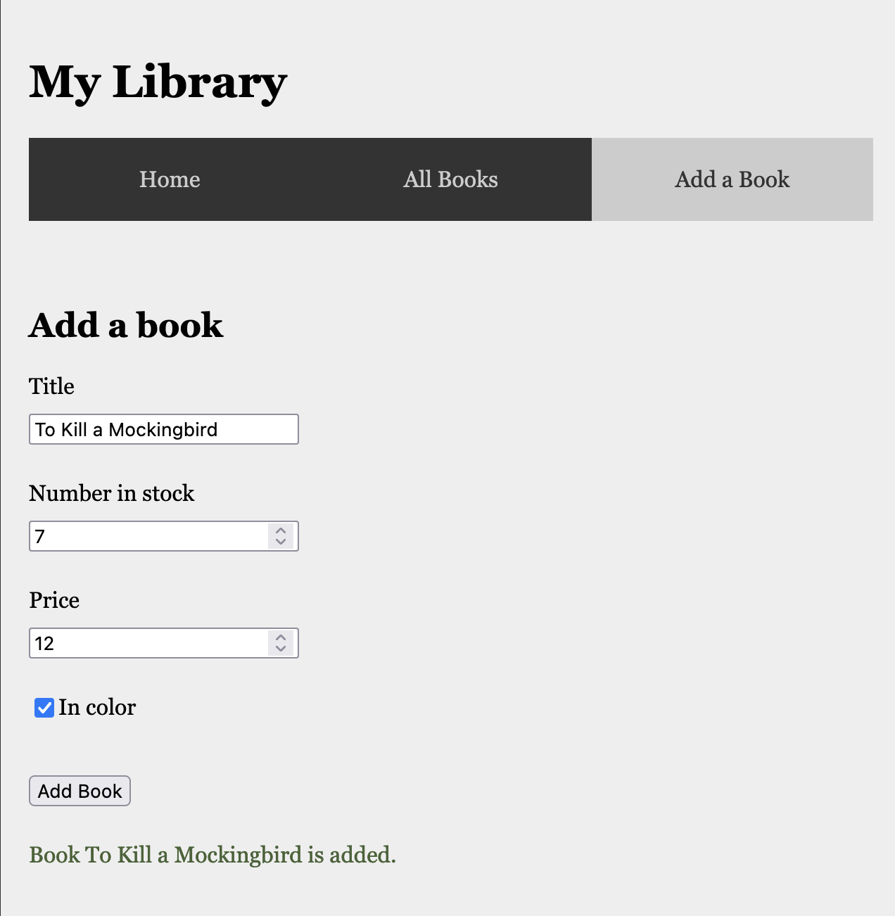

Unhappy case:

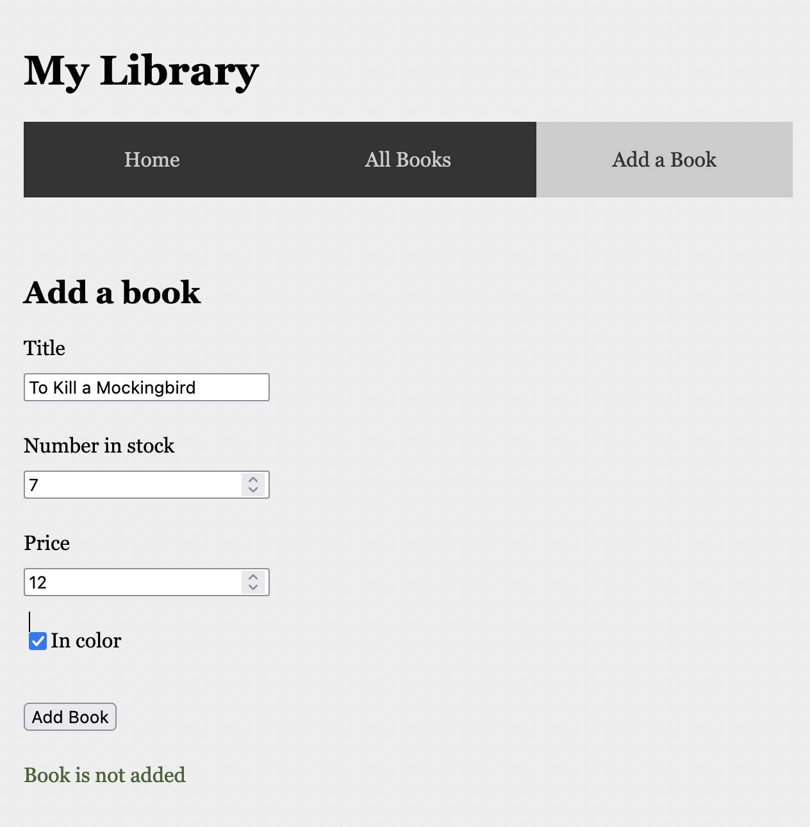

## Acceptance Criteria

* A book with given title can only be added once
* When a user fills in all fields and there is no book in the collection with the given title
  + A confirmation text with book title is shown below the form
  + the book is added to the database
  + the book is rendered on the overview page
* When a user tries to add a book with title that already is in the collection
  + the text “Book is not added” is shown below
  + the book is not added to the database

## Technical Requirements

* The book is sent to the back-end through the URL <http://localhost:8080/api/book/add>
  + POST request
  + Body: JSON object with fields “title” (String), “numberInStock” (int),

“price” (double), “inColor” (Boolean)

* + Response:
    - Happy case: JSON book object with fields “id” (int), “title” (String), “numberInStock” (int), “price” (double), “inColor” (Boolean), “priceInDollar” (double)
    - Unhappy case: empty body
* The book is stored in a h2 database